Overview of the analysis:
The purpose of the analysis is to create a summary data frame that will show ride sharing data by city type (Rural, Urban & Suburban)

Results:
- Rural cities have the least number of drivers, rides, and total fares.
- Urban cities have the greatest number of drivers, rides, and total fares.
- Suburban cities are in the middle having the 2nd most drivers, rides, and total fares.
- Although Rural cities see the least number of drivers, rides & fares the have the highest average of fare per ride and fare per driver.
- Although the Urban cities command the most drivers, rides and fares they have the lowest average of fare per ride and fare per driver.

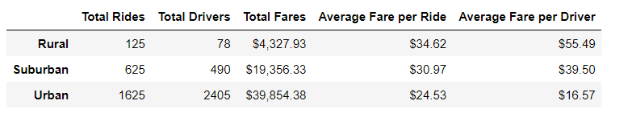

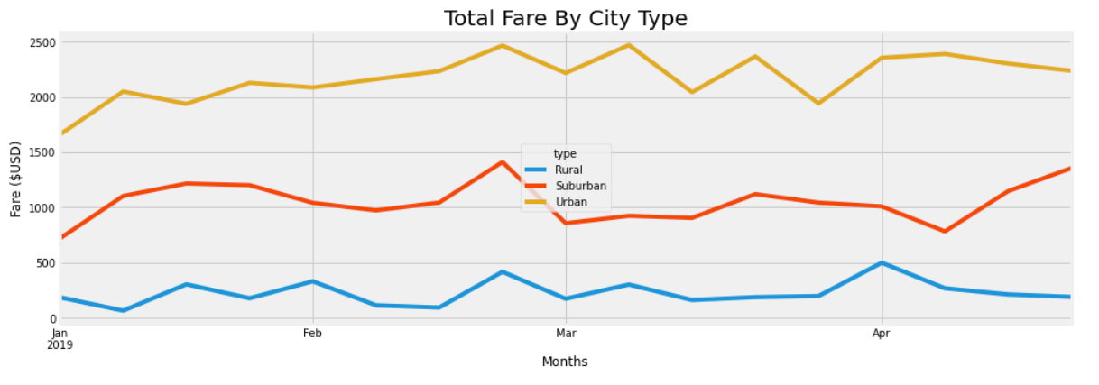
Summary:
From our data we can tell what kind of fares will be commanded based on what city type the passenger is catching a ride in. In conclusion we can effectively say that a rural area will command a higher fare because there are fewer workers that will come to this area, the travel time and distance is most likely longer making the average fare per ride & driver the most out of all city types.

Recommendations:
- Have your drivers assigned to different city types based off what type of cities they typically work in.
- Charge more per mile in urban cities because trips most likely are shorter and drivers don’t earn as much per trip.
- Make small charge increases or decreases based off how many riders there are in the city during certain months.

